|  |  |
| --- | --- |
| Canon PowerShot G7 X Mark III  Máy ảnh Canon PowerShot G7 X Mark III (Black)  PowerShot G7 X Mark III  PowerShot G7 X Mark III 1 PowerShot G7 X Mark III 3 PowerShot G7 X Mark III 4 | **Featured information:**  4.2x optical zoom (24mm - 100mm)  4K Video (no crop)  DIGIC 8 & 1.0 inch Stacked CMOS Sensor chip  Livestream support  Price: $ 800  **Specifications:**  Lens Mount  N/A  Sensor Format  N/A  Resolution  Actual: 20.9 Megapixel / Effective: 20.1 Megapixel  Size photo  5472 x 3648  Image Proportions  1:1, 3:2, 4:3, 16:9  Sensor Type  CMOS  Image Format  JPEG, Raw  Anti-Vibration  Optical |

**Overview:**

The PowerShot G7 X Mark III camera is a compact camera belonging to Canon's G-series line. With a weight of only 304g combined with two main color tones of black and silver, the G7 X Mark III is the right choice for those looking for a compact camera with a luxurious design. G7

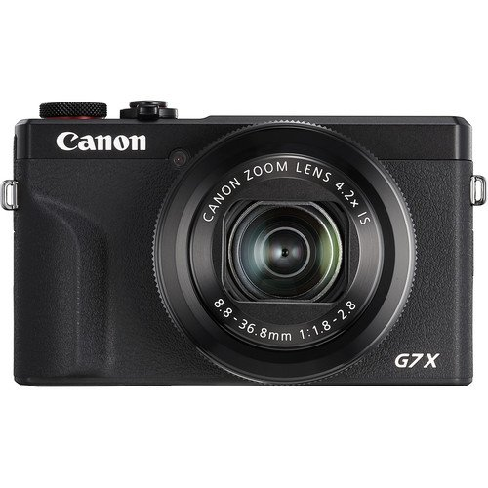

With an f/1.8- 2.8 lens and 24-120mm focal length, this camera has the ability to zoom 4.2 times to help quickly handle many shooting scenes. In particular, the camera can take clear photos in adverse lighting conditions, working well for photos that require a thin depth of field..

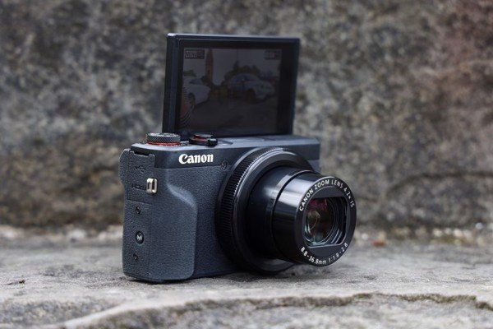

The impressive point of the PowerShot G7 X Mark III is the ability to record 4K video on a compact Canon camera. You can record 4K UHD video, HDR, slow motion without frame cropping and maintain the same resolution. In particular, the G7 This is truly an extremely useful feature for vloggers. Just connect to Wi-Fi, you can use the camera like a smartphone to broadcast live video (livestream) at events.

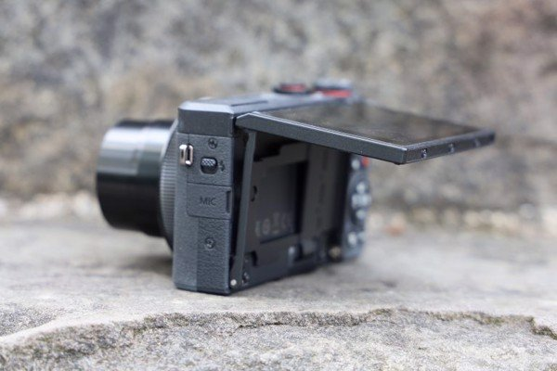

PowerShot G7 X Mark III can be charged via USB, so it is very convenient for users who have to travel a lot. Besides, this camera also easily connects to smart devices that can be controlled via Bluetooth and allows you to locate via your mobile device for more convenience during use.